Shrinkage correlation: GBPUSD and EURGBP
Method 08 / eight-major panel / delta = 0.2 and Ledoit-Wolf / Alpari D1 full available history

Study setup
Logical pair: GBPUSD , EURGBP
Broker symbols: GBPUSD_i , EURGBP_i
Snapshot: 2026-11-03_majors_alpari_D1
Timeframe: D1
Common eight-major panel window: 1999-01-06 to 2026-11-02 (UTC bar dates)
Panel matched return count n: 7127
Dropped unfinished last bar dated 2026-11-03 UTC after a tick-volume check against the prior complete day.
Fixed shrinkage: delta=0.2, mu=3.9170889e-05 (mean of diag(S))
Ledoit-Wolf estimated delta: 0.0042157642
Panel symbols: EURUSD, GBPUSD, AUDUSD, NZDUSD, USDJPY, USDCHF, USDCAD, EURGBP
Complete matched rows (Excel): GBPUSD-EURGBP_Shrinkage_D1.xlsx
Complete matched rows (HTML table): GBPUSD-EURGBP_Shrinkage_D1_data.html

Method carried forward
Shrinkage blends the sample covariance matrix S of matched daily log returns of close, ln(close_t / close_t-1), toward a simple target, then converts the shrunk covariance into correlations. Quotes are not inverted. This experiment builds one common calendar across all eight majors, forms S with the unbiased n-1 divisor, then reports two shrinkage specs: fixed delta = 0.2 with mu equal to the average sample variance (mu * I target), and sklearn Ledoit-Wolf with its estimated delta. Pair reports pull rho_ij from those panel matrices. Same-panel Pearson r is a side check only. Shrinkage improves conditioning; it is not a cause, not a lead, and not a trading signal.

Results
pearson_r | rho_02 | rho_LW | rho_02_minus_r | rho_LW_minus_r | delta_LW
-0.398603 | -0.293375 | -0.39619 | 0.105228 | 0.002413 | 0.00421576

Conclusion
Over the common 7127-day eight-major panel for GBPUSD and EURGBP (broker quote directions unchanged), fixed-delta shrinkage correlation at delta=0.2 is -0.2934 (negative, weak linear link in this sample). Ledoit-Wolf rho is -0.3962 with estimated delta=0.004216. Same-panel Pearson r is -0.3986 (rho_02 minus r = 0.1052; rho_LW minus r = 0.0024). This does not establish cause, lead-lag, or a lasting trading rule.

Charts
Daily closes
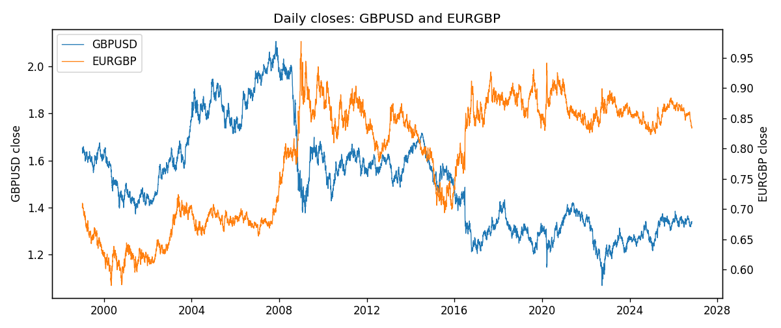
Daily log returns
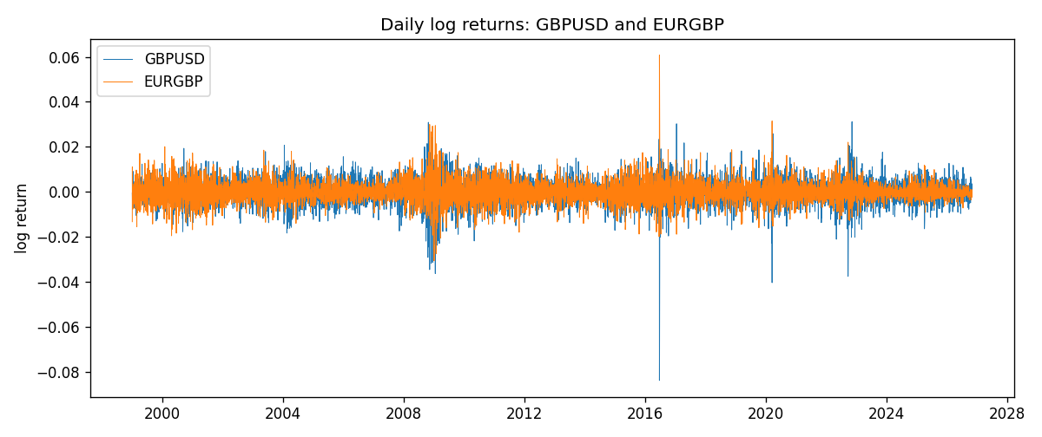
Log-return scatter
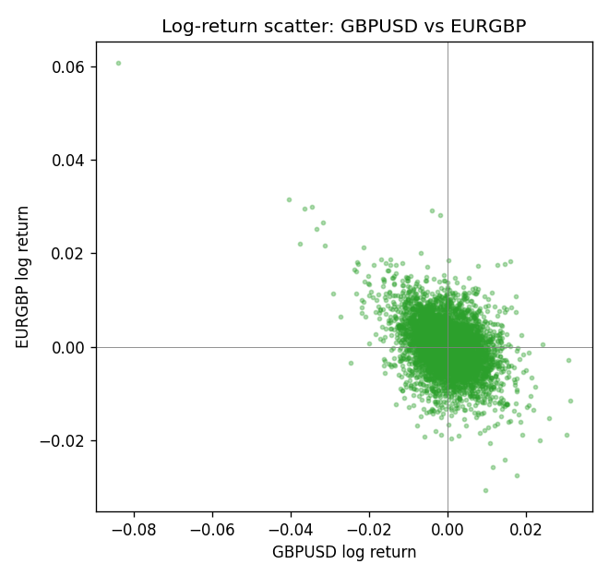

Data report
Every panel row for this pair slice is stored in the sibling Excel workbook named GBPUSD-EURGBP_Shrinkage_D1.xlsx. Full-panel covariance and correlation matrices are saved once under outputs/ as CSV files. Embedding all rows as a Word table is impractical at this length; the Word file holds the column list, column summaries, and the first and last 15 matched rows.
Columns: time, GBPUSD_open, GBPUSD_high, GBPUSD_low, GBPUSD_close, GBPUSD_tick_volume, GBPUSD_spread, GBPUSD_real_volume, GBPUSD_log_return, EURGBP_open, EURGBP_high, EURGBP_low, EURGBP_close, EURGBP_tick_volume, EURGBP_spread, EURGBP_real_volume, EURGBP_log_return
Column summaries (panel rows)
column | count | mean | std | min | 25% | 50% | 75% | max
GBPUSD_open | 7127 | 1.5143204 | 0.21800183 | 1.06854 | 1.323655 | 1.5093 | 1.62967 | 2.1066
GBPUSD_high | 7127 | 1.5206136 | 0.21856742 | 1.08366 | 1.32882 | 1.5159 | 1.636975 | 2.1161
GBPUSD_low | 7127 | 1.508003 | 0.21722806 | 1.03518 | 1.3185 | 1.501 | 1.623 | 2.0983
GBPUSD_close | 7127 | 1.5143843 | 0.21795834 | 1.06879 | 1.32373 | 1.5095 | 1.62965 | 2.1065
GBPUSD_tick_volume | 7127 | 95725.777 | 154086.85 | 62 | 10131.5 | 53562 | 92170 | 1273370
GBPUSD_spread | 7127 | 26.790936 | 19.185969 | 0 | 10 | 20 | 50 | 50
GBPUSD_real_volume | 7127 | 3.5930129e+09 | 8.4874724e+10 | 0 | 0 | 0 | 0 | 2.4038164e+12
GBPUSD_log_return | 7127 | -2.548e-05 | 0.00564718 | -0.08388241 | -0.00312586 | 3.034e-05 | 0.00318105 | 0.03112653
EURGBP_open | 7127 | 0.78791082 | 0.09637243 | 0.5734 | 0.6884 | 0.83449 | 0.8655 | 0.9769
EURGBP_high | 7127 | 0.79099288 | 0.09674788 | 0.5789 | 0.6906 | 0.83742 | 0.868415 | 0.9799
EURGBP_low | 7127 | 0.78520819 | 0.09619038 | 0.5682 | 0.6864 | 0.83222 | 0.86303 | 0.9661
EURGBP_close | 7127 | 0.7879552 | 0.09637142 | 0.5735 | 0.6884 | 0.83458 | 0.86556 | 0.977
EURGBP_tick_volume | 7127 | 87771.585 | 145890.89 | 332 | 6734 | 44866 | 82002 | 1424684
EURGBP_spread | 7127 | 21.129928 | 19.050945 | 0 | 4 | 13 | 40 | 50
EURGBP_real_volume | 7127 | 2.8086114e+10 | 1.3572254e+11 | 0 | 0 | 0 | 0 | 3.5726265e+12
EURGBP_log_return | 7127 | 2.379e-05 | 0.00487339 | -0.03067367 | -0.00262314 | -9.978e-05 | 0.00256668 | 0.06075387
First 15 panel rows (selected columns)
time | GBPUSD_close | EURGBP_close | GBPUSD_log_return | EURGBP_log_return
1999-01-06 | 1.6537 | 0.7019 | -0.00060452184 | -0.013303338
1999-01-07 | 1.6502 | 0.7097 | -0.002118709 | 0.011051402
1999-01-08 | 1.6405 | 0.7062 | -0.0058954193 | -0.004943862
1999-01-11 | 1.6312 | 0.7053 | -0.0056851331 | -0.0012752393
1999-01-12 | 1.6349 | 0.7077 | 0.0022657001 | 0.0033970309
1999-01-13 | 1.6499 | 0.708 | 0.0091330396 | 0.00042381861
1999-01-14 | 1.6531 | 0.7066 | 0.0019376331 | -0.0019793588
1999-01-15 | 1.6502 | 0.7012 | -0.0017558204 | -0.0076715819
1999-01-18 | 1.6522 | 0.7017 | 0.0012112405 | 0.00071280921
1999-01-19 | 1.6553 | 0.7007 | 0.0018745281 | -0.0014261269
1999-01-20 | 1.6472 | 0.7021 | -0.0049053846 | 0.0019960086
1999-01-21 | 1.6524 | 0.7016 | 0.0031518998 | -0.00071240297
1999-01-22 | 1.6565 | 0.7004 | 0.0024781662 | -0.0017118406
1999-01-25 | 1.6585 | 0.6966 | 0.0012066366 | -0.0054402425
1999-01-26 | 1.6597 | 0.6962 | 0.00072328374 | -0.00057438255
Last 15 panel rows (selected columns)
time | GBPUSD_close | EURGBP_close | GBPUSD_log_return | EURGBP_log_return
2026-10-13 | 1.32534 | 0.84458 | 0.0036434319 | 0.00020130374
2026-10-14 | 1.31884 | 0.84553 | -0.0049164679 | 0.0011241873
2026-10-15 | 1.32757 | 0.84479 | 0.0065976411 | -0.00087557391
2026-10-16 | 1.33257 | 0.84307 | 0.0037592051 | -0.0020380844
2026-10-19 | 1.33024 | 0.84259 | -0.0017500314 | -0.00056950988
2026-10-20 | 1.3377 | 0.83957 | 0.0055923442 | -0.0035906254
2026-10-21 | 1.33937 | 0.83839 | 0.0012476328 | -0.00140647
2026-10-22 | 1.33967 | 0.83682 | 0.00022396082 | -0.0018743924
2026-10-23 | 1.33684 | 0.83751 | -0.0021146949 | 0.00082421033
2026-10-26 | 1.33359 | 0.83762 | -0.0024340661 | 0.00013133309
2026-10-27 | 1.33044 | 0.83595 | -0.0023648393 | -0.0019957343
2026-10-28 | 1.33254 | 0.83651 | 0.0015771808 | 0.00066967224
2026-10-29 | 1.33733 | 0.83553 | 0.0035881935 | -0.0011722209
2026-10-30 | 1.33913 | 0.83351 | 0.0013450605 | -0.0024205543
2026-11-02 | 1.3406 | 0.83426 | 0.0010971256 | 0.00089940465

